**PROGRAM-3**

**Aim:** Write an algorithm and program to sort n numbers using Bubble sort technique.

Algorithm :

1. Starting with the first element(index = 0), compare the current element with the next element of the array.
2. If the current element is greater than the next element of the array, swap them.
3. If the current element is less than the next element, move to the next element. Repeat Step 1.

**Source code:**

1. **USING ITERATION**

#include <stdio.h>

#include<conio.h>

#define MAXSIZE 10

void main()

{

int array[MAXSIZE];

int i, j, num, temp;

printf("Enter the value of num \n");

scanf("%d", &num);

printf("Enter the elements \n");

for (i = 0; i < num; i++)

{

scanf("%d", &array[i]);

}

for (i = 0; i < num; i++)

{

for (j = 0; j < (num - i - 1); j++)

{

if (array[j] > array[j + 1])

{

temp = array[j];

array[j] = array[j + 1];

array[j + 1] = temp;

}

}}

printf("Sorted array is:\n");

for (i = 0; i < num; i++)

{

printf("%d\t", array[i]);

}

getch();

}

**OUTPUT:**

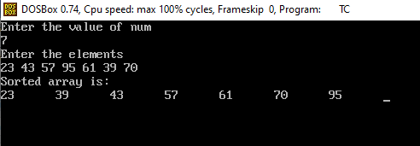

1. **USING RECURSION**

**Source code:**

#include<stdio.h>

#include<conio.h>

void Recursion(int a[],int num);

void main()

{

int i,j,num,temp,a[10];

clrscr();

printf("Enter number of elements\n");

scanf("%d",&num);

printf("Enter numbers\n");

for(i=0;i<num;i++)

{

scanf("%d",&a[i]);

}

Recursion(a,num);

printf("Ascending oreder of given numbers is\n");

for(i=0;i<num;i++)

{

printf("%d\t",a[i]);

}

getch();

}

void Recursion(int a[],int num)

{

int i,j,temp;

i=num;

if(i>0)

{

for(j=0;j<num-1;j++)

{

if(a[j]>a[j+1])

{

temp=a[j];

a[j]=a[j+1];

a[j+1]=temp;

}

}

Recursion(a,num-1);

}

else

{

return;

}

}

**OUTPUT:**

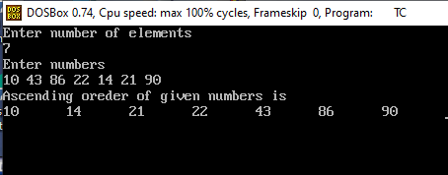

**Complexity:**

Best case: O(n)

Worst case: O(nˆ2)

Average case: O(nˆ2)